Banking Credit Card Fraud Detection Sample Readme
This decision service shows how to leverage business rules to process credit card transactions and perform the following verifications: data validation, authorizing transactions, fraud detection.

Download and install
This project be downloaded individually. Import the project into Rule Designer:
Click File > Import > Expand General > Select Existing Projects into Workspace, and click Next. Browse to the downloaded project.

The purpose of the decision service is to detect the credit card fraud. Input parameters are all based in XML Schemas, so the resulting decision service can be easily be called as a HTDS. This is the XOM being used by the rules:
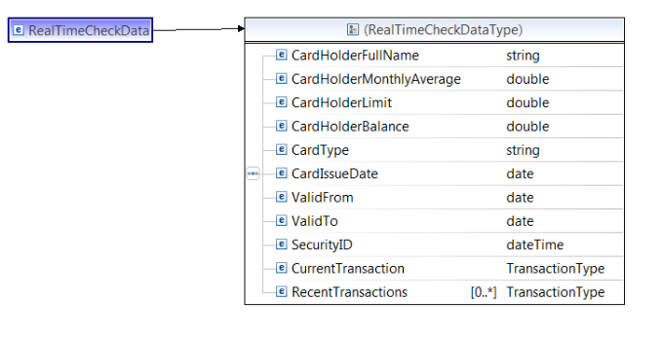
The Schema is being used for input and output is boolean and Strings.
The overall process is as follows (Main flow on the left, Fraud sub-flow on the right):
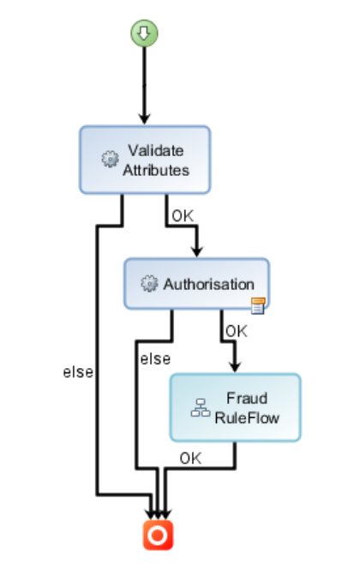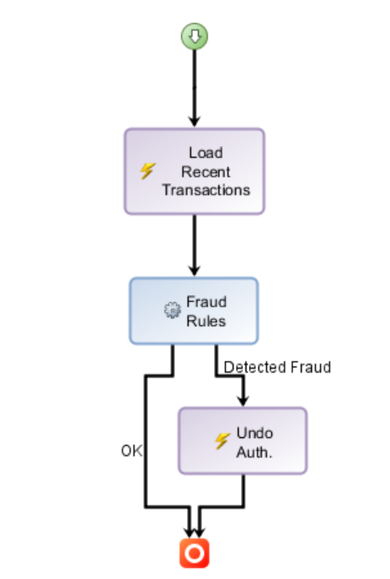

Content includes:
* Rules & BOM in one package
* Invented Card transaction XSD that includes account and recent TXN data
* DVS test scenario spreadsheet
* Two XML files to test rules once deployed to the RES
* Enhanced BOM to provide useful rule language features
* Queries, Templates, Ruleset variables, Ruleset Parameters, BOM Domain Values
* Helper functions to manipulate date, currency and case management

History changes
Version: 8.7.0 (Feb 19, 2015)
First version published to Bluemix DevOps
. migrated to 8.7 and new Decision Service
. removed xls format scenario

Version 8.5.0 - July 19, 21013
. migrated to ODM 8.5
. fixed CountriesDomainType domain issue by synchronizing.

Version 8.0.0 - July 19, 212
. migrated to WODM 8
. duplicate xls scenario to have a 2010 version (.xlsx)
. fixed .rulepackage name to match package name in Designer

Version 7.5.0.1 - April 2, 2012
. migrated to WODM 7.5.0.1
. added 3 new virtual BOM methods in RulesHelpers: fraudTx, invalidData, rejectTX
. refactored all rules to make the action phrases more business friendly

Version 7.1.1.1 - Dec 16, 2010
. migration to JRules 7.1.1.1

